1. Find the details of male members from the data file.

Head -10 data.text | grep -h “Male” data.text

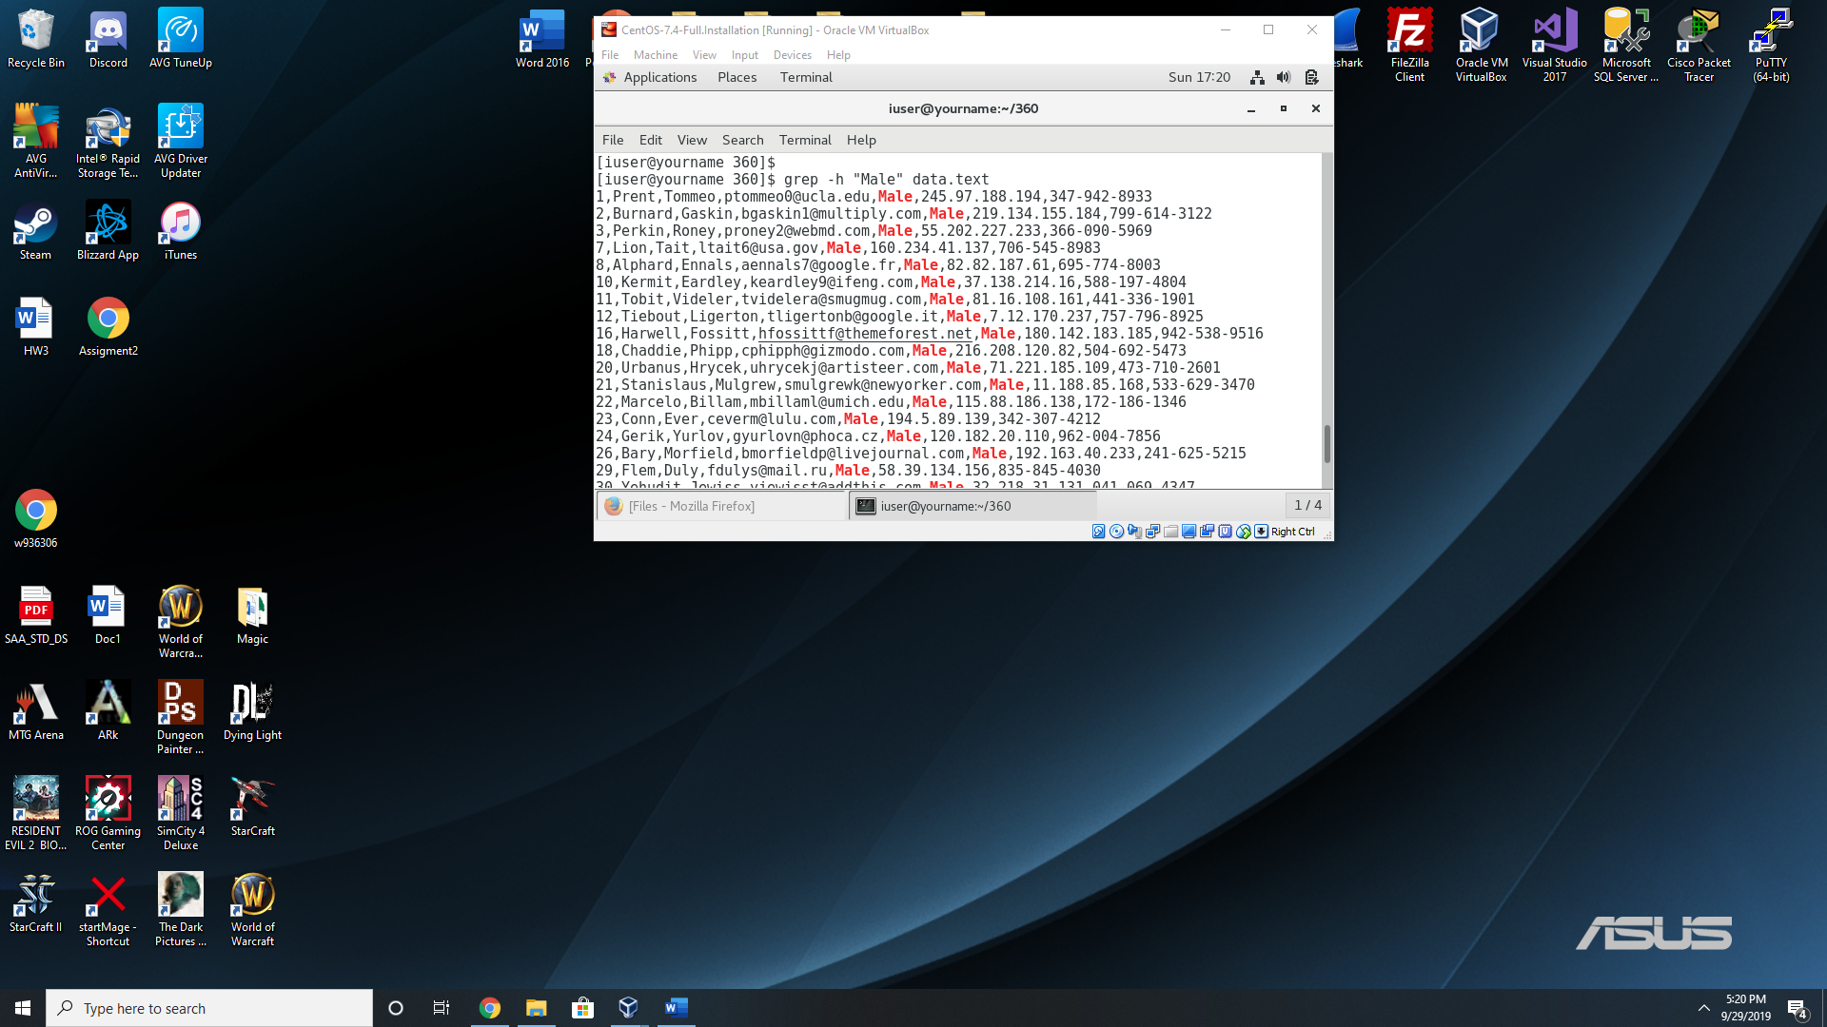

1. Find the details of members whose name starts with either ‘A’ or ‘K’.

grep -h ‘[A||K]’ data.text

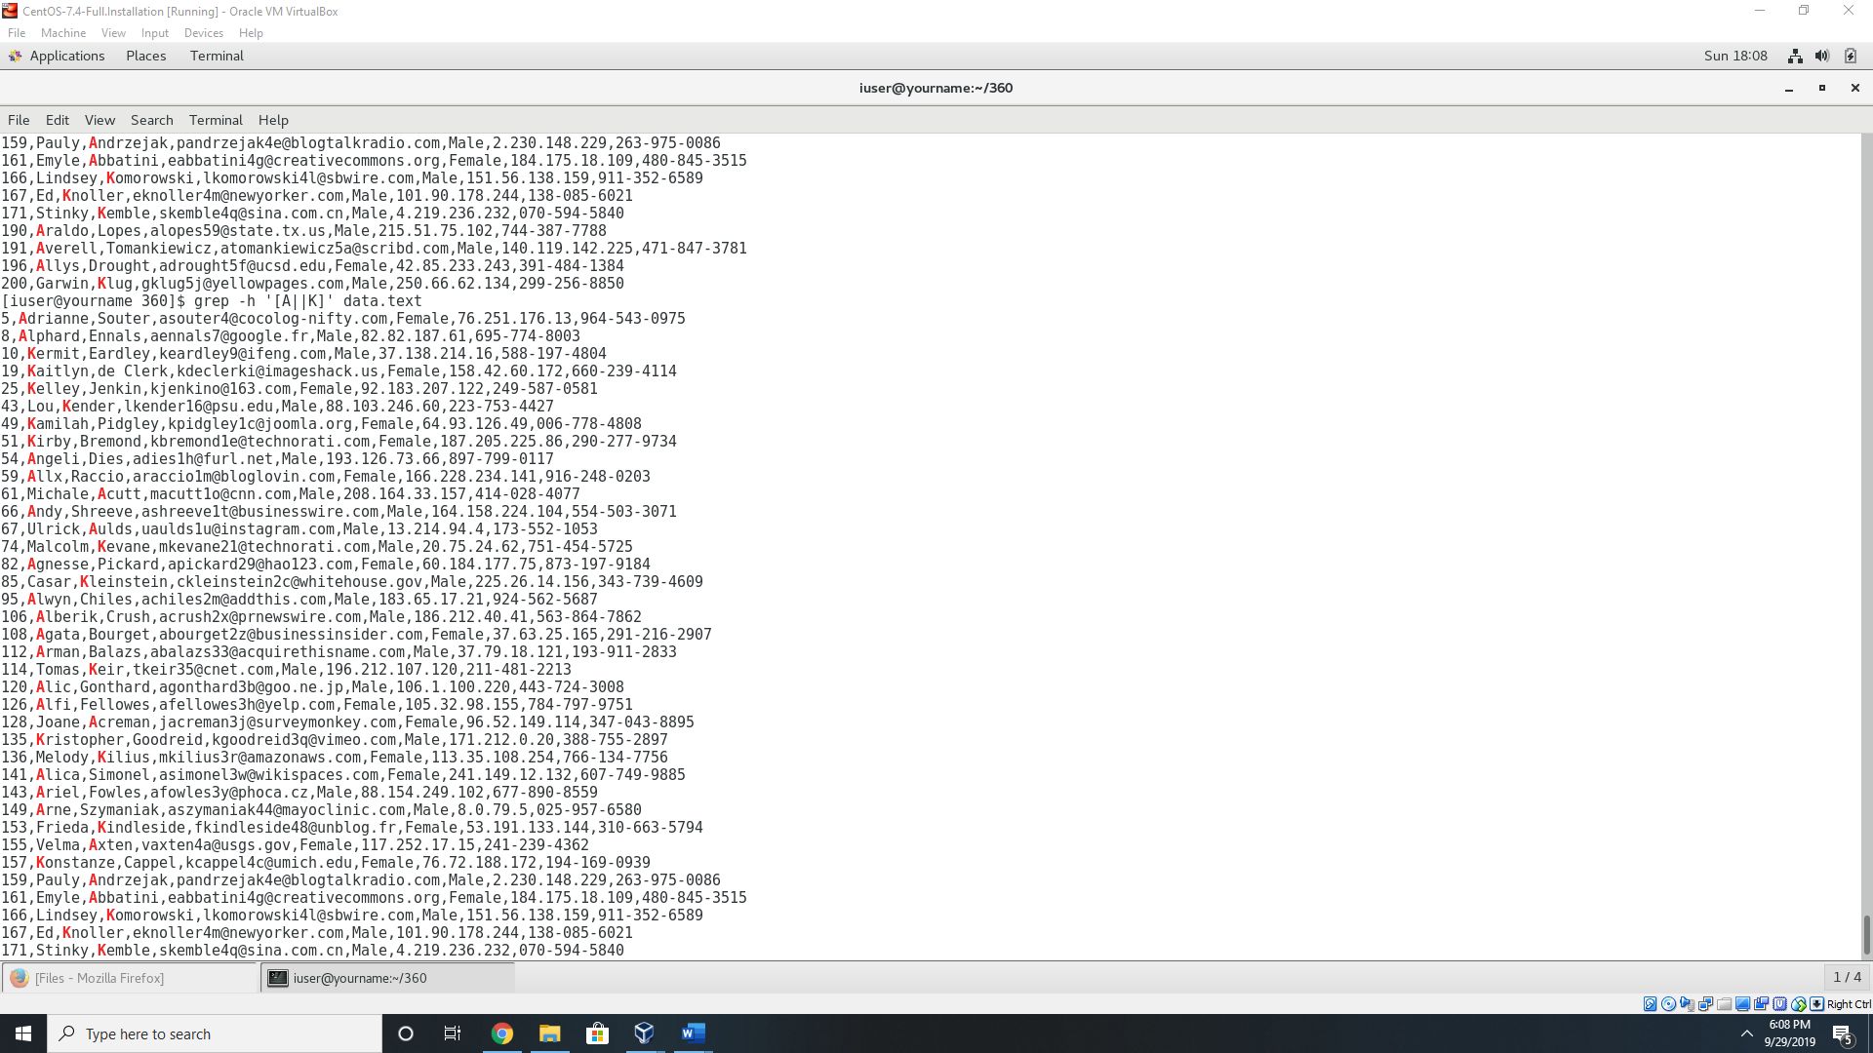

1. Write a command to find only phone numbers from the data file.

Grep -oP “…-…-….” data.text

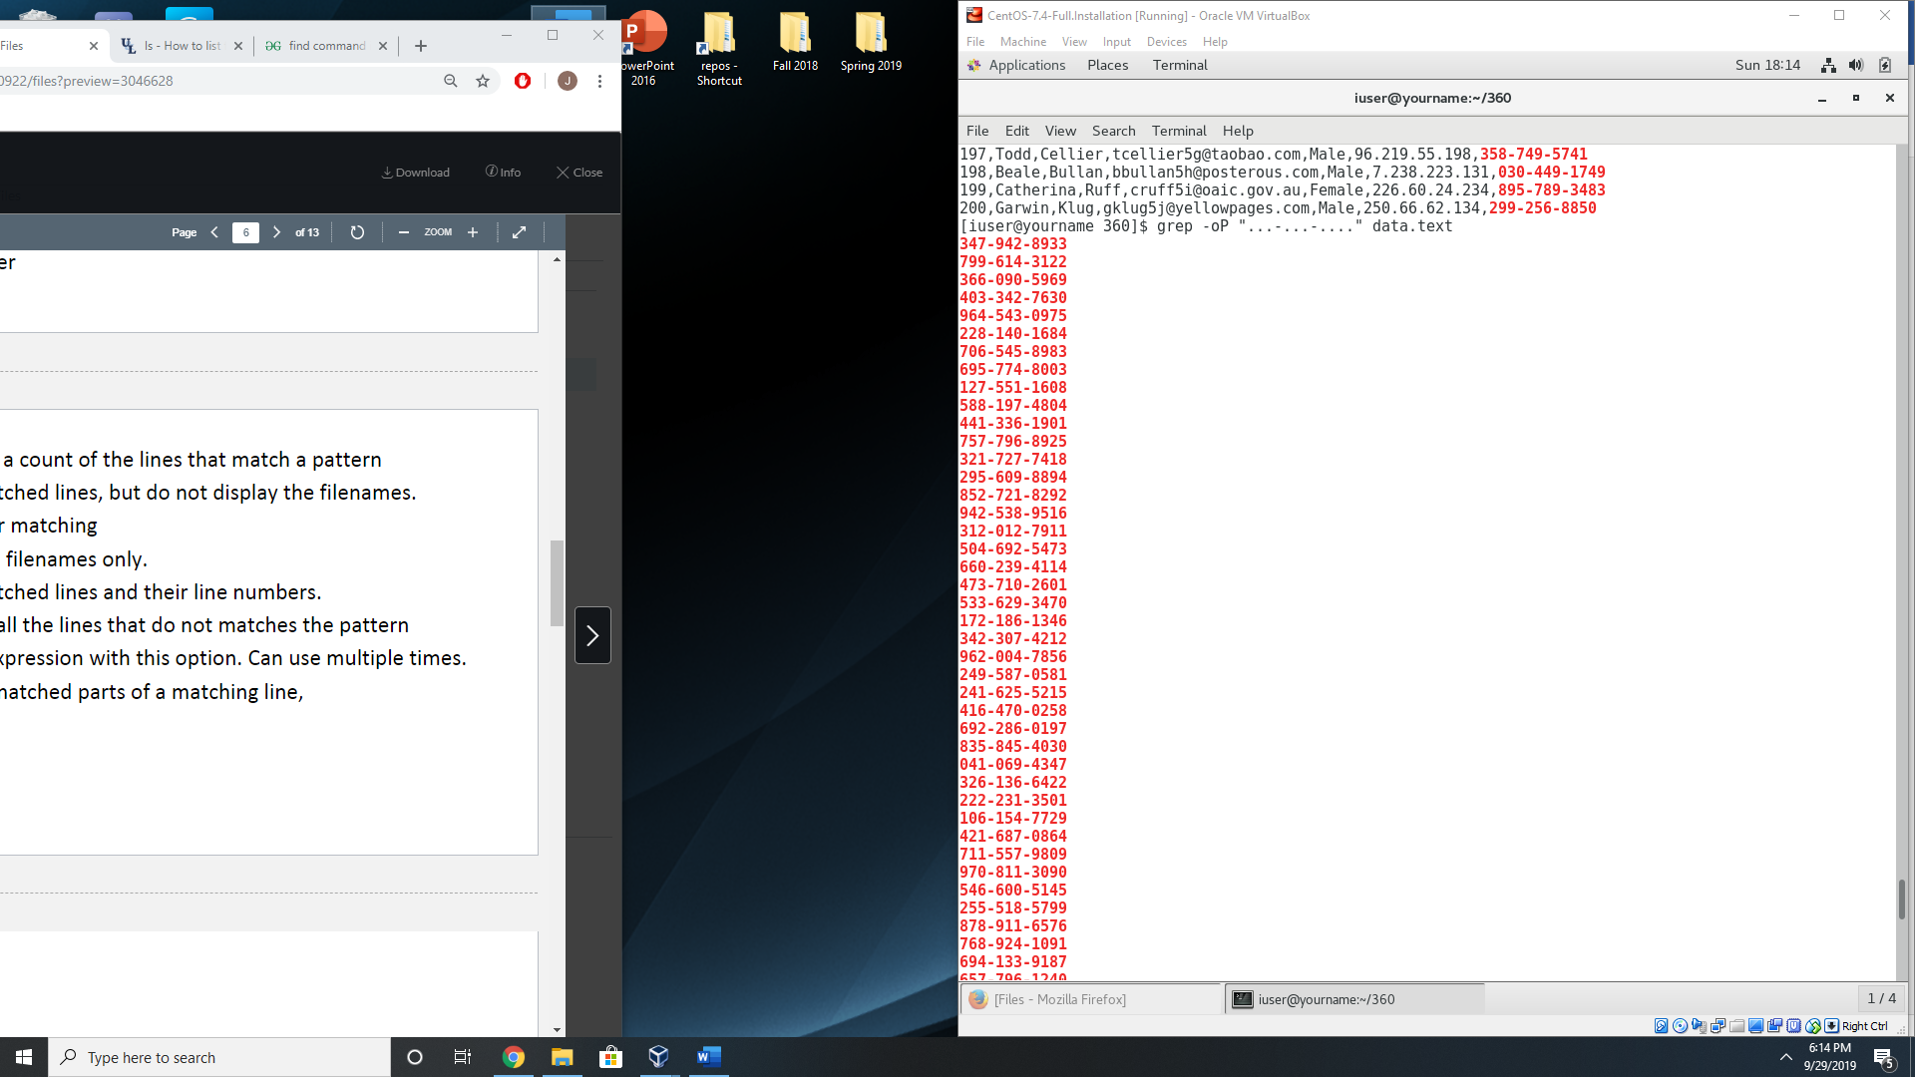

1. Store the data of each column to a new file and name the file as per the column name.

cut -d “,” -f1 data.text > id.text | cut -d “,” -f2 data.text> first_name.txt | cut -d “,” -f3 data.text> last_name | cut -d “,” -f4 data.text> email.text | cut -d “,” -f5 data.text> gender.text | cut -d “,” -f6 data.text> ip_address.text | cut -d “,” -f7 data.text> phone.text

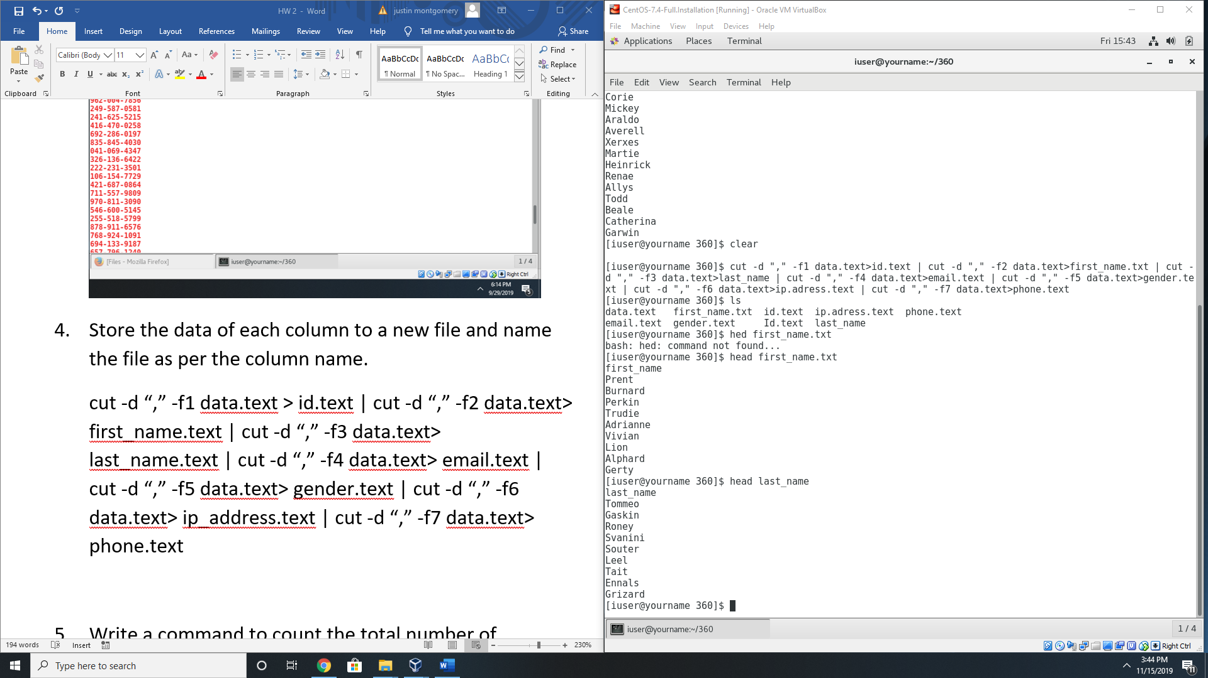

1. Write a command to count the total number of members in the file.

Grep -c ‘[0-201].*’ data.text

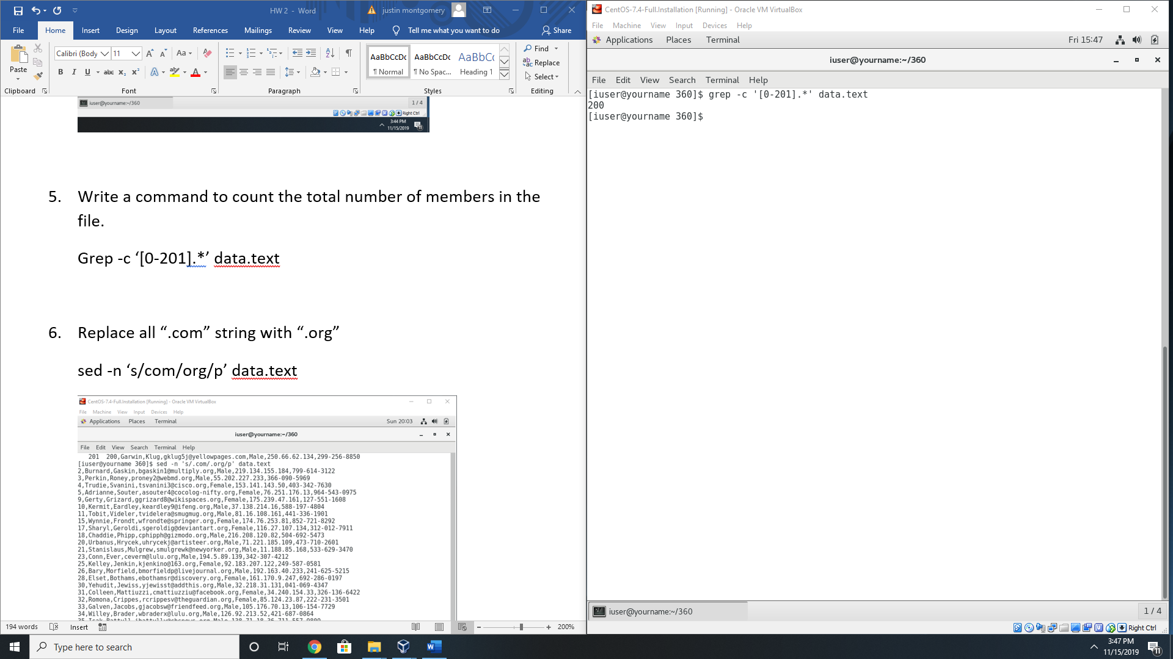

1. Replace all “.com” string with “.org”

sed -n ‘s/com/org/p’ data.text

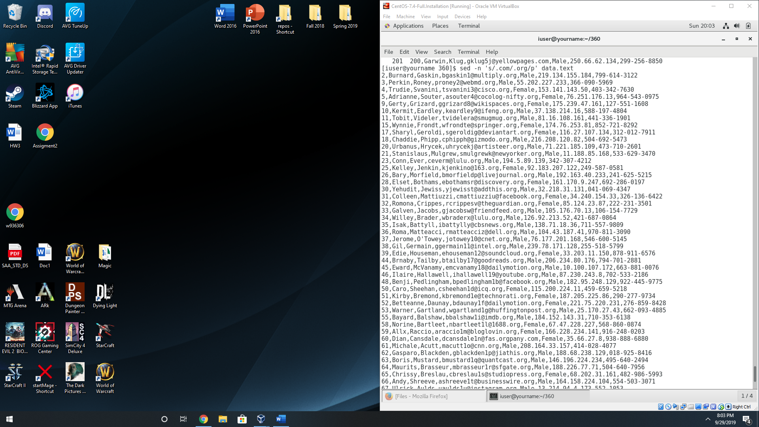

1. Parenthesize first character of the first and last name of each member.

Sed ‘s/[A-Z/(&)/1’ data.text | sed ‘s/[A-Z/(&)/2’

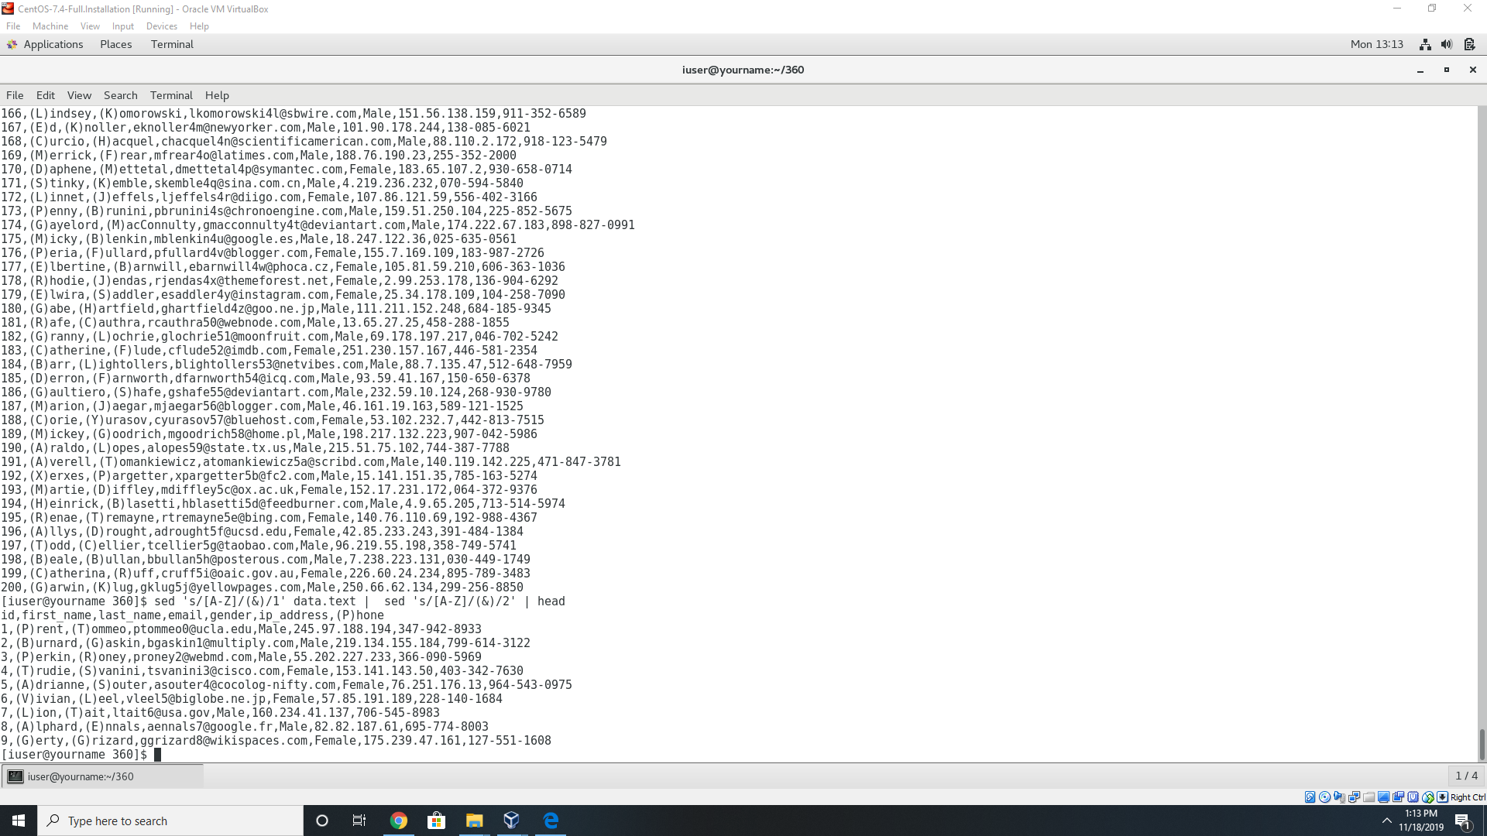

1. Write a command to delete a particular line (say the 10th line) from a file.

Sed ‘10d’ data.text

1. Number each line of a file.

Cat -n data.text

